SPONSORSHIP PROPOSAL

2021 - 2022



TEAM PINAKA

A STUDENT SPACE TECHNOLOGY TEAM

Lovely Professional University, Punjab

**About Us**

**Lovely Professional University**

Lovely Professional University (LPU) is a private university located in Chaheru, Phagwara, Punjab, India. The university was established in 2005 by Lovely International Trust, through the Lovely Professional University Act, 2005 (Punjab Act 25 of 2005) and started operation in 2006. The university campus is spread in 112 acres on the Jalandhar-Delhi GT Road. The university is founded and governed by chancellor Ashok Kumar Mittal, while administration and operations are governed by his wife Rashmi Mittal as the pro-chancellor of the university. Team Pinaka is affiliated with Lovely Professional University and functions as one of the technical teams present in the college. Team Pinaka is the sole technical team focused on space technology and is one of the most prestigious and respected teams in the entire college.

******IN-SPACe Model Rocketry**

IN-SPACe Model Rocketry India Student Competition 2024-25 is being organized by Astronautical Society of India in association with ISRO. This competition is aimed to provide a realistic experience to students and start-ups, in designing and launching an amateur rocket that meets a specified set of mission requirements. The competition involves the design, development & launch of a Model Rocket carrying a payload of 1Kg mass to an altitude of 1000m above the launch site, along with safe ejection of the payload and safe landing of the rocket.

**Development Process**

The development of the rocket spans about a year. The first stage of the development begins with preliminary research to develop feasible concepts and the mission timeline. Several technical sessions help us finalise the design through analysis and validation. Small prototypes are built during the course of the semester to test and analyse the designs. Once the designs are properly validated, manufacturing files are created and sent off to the local manufacturers. The manufacturing phase of the rocket will be concluded by the end of March. Several pre-assembly tests are done and the rocket finally enters into the Assembly, Integration and Testing phase. Rigorous testing is done on the rocket to ensure that the rocket holds true to the name and reputation of the team. Once the rocket is ready, it is finally shipped to the competition. To keep on track with the proposed timeline, the team requires adequate funds and industrial support. Initially the team was supported with a seed money of **Rs. 1,50,000** by the college to realise the prototype at the start of the financial year. The budget of the entire project is estimated to be around **Rs. 9,00,000**. To meet the deficit, the team always looks for support and industrial collaborations.

|  |  |  |  |  |
| --- | --- | --- | --- | --- |
| **PROJECT BUDGET**  Project Title: **ReSOLV-Mk-I** Estimated Total Cost: ₹ **9,19,382.00** | | | | |
| **Subsystem** | **Description** | **Cost (₹)** | | **Total (₹)** |
| **EM** | **FM** |
| **Aerostructures** | Rocket stability, Drag reduction and design of a robust structure | 84,549.00 | 2,04,549.00 | 2,89,098.00 |
| **Avionics** | Powering and guidance of Rocket | - | 42,016.00 | 42,016.00 |
| **Propulsion** | Provides thrust to reach the apogee | 36,830.00 | 77,895.18 | 1,14,725.18 |
| **Recovery** | Safe retrieval of Rocket | 36,300.00 | 50,600.00 | 86,900.00 |
| **Payload** | Objective of the rocket | 34,840.00 | 49,990.00 | 84,830.00 |
| **SA Cup Fee** | Rocket fee and Team registration fee | - | 1,31,812.65 | 1,31,812.65 |
| **Logistics** | Shipping and customs charges | - | 1,70,000.00 | 1,70,000.00 |
| **Total** | | **1,92,519.00** | **7,26,863.00** | **9,19,382.00** |

**OUR WORK – A PICTORIAL REPRESENTATION**

The technical progress of the team has been in leaps and bounds. A few technical milestones are depicted below in a more perceptible manner.

*Figure 1: OpenRocket model of ReSOLV-1*

*Figure 3: Avionics Bay of Insight-1*

*Figure 2: Nose Cone of Insight-1*

*Figure 4: Structural Analysis of Insight-1*

*Figure 5: 3D CAD Model*

*Figure 6: Static Fire Test Stand Figure 7: CFD Analysis*

*Figure 4: Prototype Figure 5: Production and Manufacturing*

**OUR TOOLS**

**Sponsorship Levels**

With the help solicited, we will be able to succeed in the completion of such projects and compete in competitions like the Spaceport America Cup. Your contributions will also serve as a morale booster in the completion of our RVSAT-1 project. A sponsorship chart is depicted below which is the sponsorship standard that Team Antariksh uses. Benefits from the team will be provided in every possible way the team can, based on the monetary value of your support. The team is willing to work out any other way so that we end up with a mutually beneficial partnership.

* + Platinum (₹3,00,000 and above)
  + Gold (₹1,00,000 and above)
  + Silver (Upto ₹1,00,000)

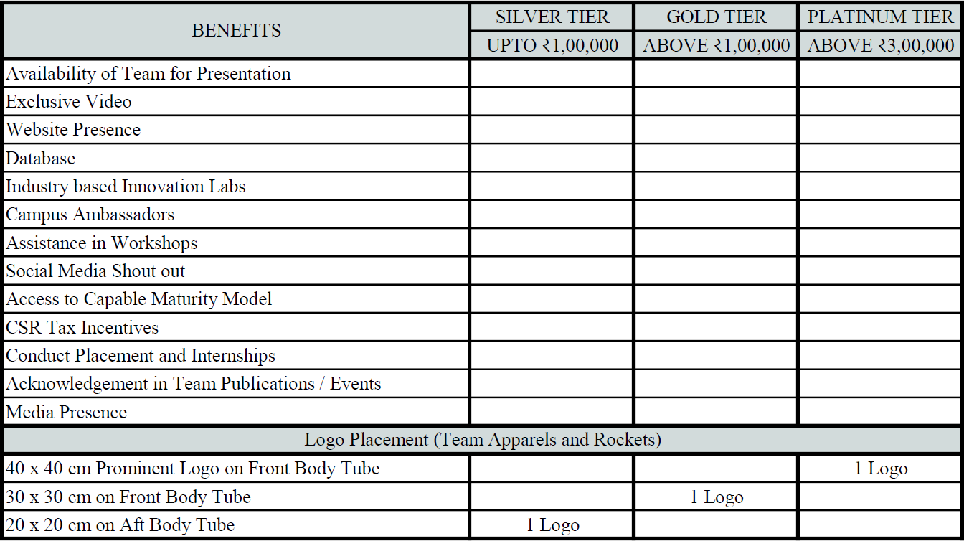

* Benefits are liable to change based on the discussions between the two parties

**CONTACT US**

**Avaneeth Anil**

Project Manager

+91 97411 40961

[projectmanager@teamantariksh.in](mailto:projectmanager@teamantariksh.in)

**Ninad Gajanan**

Deputy Project Manager

+91 79997 67911

**Tejus Sankar**

Head of Sponsorship, Marketing and Publicity

+91 99724 45385

[parnterwithus@teamantariksh.in](mailto:parnterwithus@teamantariksh.in)

**Faculty Advisor**

Dr. Ravindra S Kulkarni Professor and Head

Department of Aerospace Engineering R V College of Engineering

+91 99456 02861

[ravindraskulkarni@rvce.edu.in](mailto:ravindraskulkarni@rvce.edu.in)

**Mailing Address**

Team Antariksh – Room 407, IDRC block, RV College of Engineering, RV Vidyaniketan Post, Mysore Road, Bengaluru, Karnataka – 560059

[contactus@teamantariksh.in](mailto:contactus@teamantariksh.in) [www.teamantariksh.in](http://www.teamantariksh.in/)

LinkedIn: users report service instability - Olhar Digital@teamantarikshofficial Team Antariksh